2. R2RML Mappings Language and Motivating Example
This section briefly overviews the R2RML mapping language, and presents a motivating example.
R2RML is a language for expressing customized mappings from relational databases to RDF datasets. An R2RML mapping refers to logical tables to retrieve data from the input database. A logical table can be: (1) a base table; (2) a view; and (3) a valid SQL query (called an “R2RML view” because it emulates an SQL view without modifying the database).
Each logical table is mapped to RDF using a triples map, which is a rule to map each row in a logical table to a set of RDF triples. The rule has two main parts: a subject map and multiple predicate-object maps. The subject map generates the subject of all RDF triples that will be generated from a logical table row. The subjects are often URIs generated from the primary key values. The predicate-object maps in turn consist of predicate maps and object maps (or referencing object maps). Triples are generated by combining the subject map with a predicate map and object map, and applying these three maps to each logical table row.
In following, we present our case study, and then we show some examples of R2RML mappings, which illustrate some of the difficulties in generating mappings using R2RML.
Figure 1 depicts the relational schema ISWC_REL. Each table has a distinct prima- ry key, whose name ends with 'ID'. Persons and Papers represent the main concepts. The attribute conference of Papers is a foreign key to table Conferences. Rel_Person_Paper represents an N:M relationship between Persons and Papers. The
labels of the arcs, such as Fk_Publications, are the names of the foreign keys.
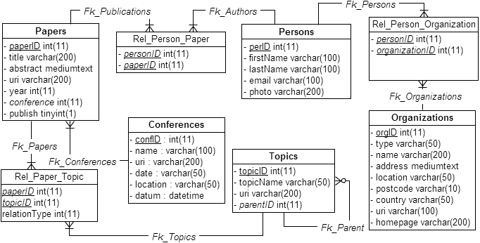
Figure 1. ISWC_REL Database Schema.
Figure 2 depicts the ontology CONF_OWL, which reuses terms from four well- known vocabularies: FOAF (Friend of a Friend), SKOS (Knowledge Organization System), VCARD and DC (Dublin Core). We use the prefix “conf” for the new terms defined in the CONF_OWL ontology.
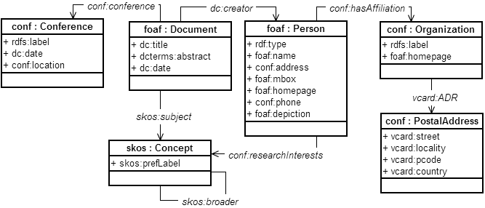
Figure 2. CONF_OWL Target Ontology.
The R2RML mapping in Table 1 refers to base table Persons_Rel (line 2). This mapping specifies that each tuple t in Persons_Rel produces three RDF triples:
(i) <http://example.com/person/t.perID> rdf:type foaf:Person.
(Generated from subject map in lines 3-5)
(ii) <http://example.com/person/t.perID> foaf:name concat(t.firstname, t.lastname). (Generated from predicate map in lines 6-8)
(iii) <http://example.com/person/t.perID> foaf:mbox “t.email”.
(Generated from predicate map in lines 9-11)
Table 1. R2RML Mappings refering to base table Persons_Rel
1 | <#PersonTriplesMap>
2 | rr:logicalTable [ rr:tableName "Persons_Rel" ];
3 | rr:subjectMap [
4 | rr:template "http://example.com/person/{perID}";
5 | rr:class foaf:Person; ];
6 | rr:predicateObjectMap [
7 | rr:predicate foaf:name;
8 | rr:objectMap [ rr:template "{firstName} {lastName}"]; ];
9 | rr:predicateObjectMap [
10 | rr:predicate foaf:mbox;
11 | rr:objectMap [ rr:column "email" ]; ].
The R2RML mapping in Table 2 refers to base table Organizations_Rel (line 2). This mapping specifies that each tuple t in Organizations_Rel produces three RDF triples:
(i) <http://example.com/org/t.orgID> rdf:type conf:Organization.
(Generated from subject map in lines 3-5)
(ii) <http://example.com/org/t.orgID> foaf:label “t.name”.
(Generated from predicate map in lines 6-8)
(iii) <http://example.com/org/t.orgID> foaf:homepage “t.homepage”.
(Generated from predicate map in lines 9-11)
Table 2. R2RML Mappings refering to base table Organizations_Rel
1  2  3  4  5  6  7  8  9  10  11 | <#OrgTriplesMap>  rr:logicalTable [ rr:tableName "Organizations_Rel" ];  rr:subjectMap [  rr:template http://example.com/org/{orgID}  rr:class conf:Organization; ].  rr:predicateObjectMap [  rr:predicate foaf:label;  rr:objectMap [ rr: column "name"]; ];  rr:predicateObjectMap [  rr:predicate foaf:homepage;  rr:objectMap [ rr: column "homepage"]; ];

The R2RML mapping in Table 3 refers to base table Rel_Person_Organization (line 2) to link individuals of class foaf:Person with individuals of class conf:Organization via conf:hasAffiliation object property. Attribute perID is used to compose the same URI of PersonTriplesMap (line 3 of Table 3 is equal to line 4 of Table 1). This mapping performs a join between Rel_Person_Organization and Organizations_Rel, on the organizationID and orgID attributes (lines 8-10). The mapping specifies that for each pair <t,t’>, where t is a tuple in Rel_Person_Organization, t’ is a tuple in Organizations_Rel, and t.organizationID = t’.orgID, it generates one triple:
<http://example.com/person/t.perID> conf:hasAffiliation
<http://example.com/org/t’.orgID>
Table 3. R2RML Mappings refering to base table Rel_Person_Organization
1 | <#HasAffiliationTriplesMap>
2 | rr:logicalTable [rr:tableName "Rel_Person_Organization" ];
3 | rr:subjectMap [ rr:template"http://example.com/person/{perID}"; ];
4 | rr:predicateObjectMap [
5 | rr:predicate conf:hasAffiliation;
6 | rr:objectMap [
7 | rr:parentTriplesMap <#OrgTriplesMap>;
8 | rr:joinCondition [
9 | rr:child “organizationID”;
10 | rr:parent “orgID”;]; ]; ].

The R2RML mapping in Table 4 refers to R2RML view (RV), defined in lines 3-6. The object map in lines 8-14 maps tuples of RV to triples of the object property conf:researchInterests. Note that this mapping can not be directly defined referring to a base table, because the rr:joinCondition term in an rr:objectMap can have only one foreign key referenced. So, in this case, we have to define a view to directly relate a person with his/her topics of interest. The mapping specifies that for each pair <t,t’>, where t is a tuple in RV, t’ is a tuple in Rel_Paper_Topic, and t.idTopic = t’.topicID, it generates one triple:
<http://example.com/person/t.idPerson> conf:researchInterests
<http://example.com/topic/t’.topicID>
Motivated by the need for a method to support the deployment of mappings using R2RML, we propose correspondence assertions as a convenient way to specify the mapping between a target vocabulary and a base relational schema. Then, we proposed an approach to automatically generate R2RML mappings, based on a set of correspondence assertions. The approach uses relational views as a middle layer, which facilitates the R2RML generation process.
Table 4. R2RML Mappings refering to an R2RML View
1 | <#ResearchInterestsTriplesMap>
2 | rr:logicalTable [
3 | rr:sqlQuery """
4 | SELECT pe.perID as idPerson, rpt.topicID as idTopic
5 | FROM Persons_Rel as pe, Rel_Person_Paper as rpp,  Papers_Rel as pa, Rel_Paper_Topic as rpt
6 | WHERE  pe.perID = rpp.personID and rpp.paperID = pa.paperID and  pa.paperID = rpt.paperID]; """
7 | rr:subjectMap [rr:template "http://example.com/person/{idPerson}";];
8 | rr:predicateObjectMap [
9 | rr:predicate conf:researchInterests;
10 | rr:objectMap [rr:template http://example.com/topic/{ idTopic }];];

